# 9-1 Final Project:

# [Info Tech Project/Team Mgmt.](https://learn.snhu.edu/d2l/home/1086809)

# Submission

James Osibogun

SNHU

Professor Dajani

Table Of Contents

**Executive Summary**

**Introduction**

**Team Dynamics**

## **Conflict Resolution Leadership**

**Project Status**

**Analyzing**

**Variance**

**Scope creep**

**Baseline**

**Actions**

**Communication Plan**

**Clarification**

**Project Strategy**

**Project Communications Planning**

**Project Cost Planning and Control:**

**Key Performance Indicators:**

**Project Schedule Planning:**

**Inputs necessary to the precedence diagram include the following:**

**Forward pass:**

**Backward Pass:**

**Project Risk Planning:**

**Risk Control**

**Conclusion**

**Executive Summary**

The Coronavirus has problematically engulfed the hospital with patients with extreme illnesses in late 2014. More than two years later, certain countries have experienced the Coronavirus or symptoms.

The monkeypox virus has started controlling the world overnight overwhelming hospitals. Today the virus still plagues countries with a new virus on the horizon called Monkeypox. Major hospitals need to expand their database for the new demand for patients in their Clinical Database.

On May 5, 2017, we will kick off the project. The Medical Informatics case project will Handle the wellness vendor data to ensure that members' preventative care is being tracked. It will include changes to the data tables and create a vendor report. The date for launch is December 21, 2017.

**Introduction**

The Medical Informatics case study requires resolving conflicts within project teams and delivering several documents. The Medical Informatics case study to complete a draft of the scope, cost, and quality planning report.

Certain situations that arise during projects are team dynamics, leadership, reporting structure, motivation, and confidence. As the project is completed, notes must be saved for other projects. A strong communication plan and risk planning is the best course of action as progression continues.

The new Datawarehouse must be

* Subject-oriented
* Integrated
* A timestamp usually identifies them.
* Nonvolatile, that is, nothing was added or removed.
* The rows in the tables support the operational database.

Load all data into the database when they exceed a well-defined date. It must be queried with a response return to reflect historical information. The data collected must be Initially ***static*. Any** data that is updated will not be ***active*** in the data warehouse. The Teradata solutions must include strategic and tactical queries in an Active data warehouse (Teradata, n.d).

Teradata database management tools ensure that the database can keep pace with changing requirements for addition of new users in the business application. Chip rewards and Spire are the vendors that will get the scripts on a weekly basis. Scripts will be executed monthly using MDLive.

## **Team Dynamics**

Team dynamics is important for starting and finishing projects, maintenance, and record keeping. Understanding group dynamics is now considered an essential part of leadership. Positive team dynamics include trust, self-correcting behavior, constructive criticism and mutual understanding (Rally Bright). Trust, communication, and skills will propel the project to completion. On time. Free from error. Customer satisfaction.

## **Conflict Resolution Leadership**

Leadership styles can help a project team move forward with a project by the leadership style of the project manager. They can be:

* Transactional
* Transformational
* Servant
* Democratic
* Autocratic
* Bureaucratic
* Laissez-Faire

The PM should decide who they are and not decide to be another kind of PM. They were hired because they delivered completed projects in the past, decent resume, or the hiring managers have already a knowledge of what the PM styles. Since this is a medical vendor there are two perfect leadership styles that would benefit the project, stakeholders and the team. The PM must be either a democratic leader, servant Transactional, or transformational (Micro Mentor).

A PM leadership style will have an impact on the team member by impacting motivation and confidence. The team will be on point and on target with a Servant, transactional, or a transformational leader.

The vendor project will need the team to have a good leader. The PM works for the project team by giving them the tools they need to complete the project. PM will also be the mentor to the team in case they get replaced due to sickness, or family issues.

**Project Status**

The project team has no training in Agile methodologies. The legal department said they could not provide the policy document wording in time (SNHU). A progress report and deliverable have complete risks, issues, and cost information (SNHU). The project is over budget by 20%, and the vendor asks for pre-payment for the third and final module. There is no communications plan (SNHU).

In the table below it will describe what the problem description is, the root cause, Proposed resolution, and proposed preventable action for the future. The result of these issues will be decreased before the next project.

|  |  |  |  |  |
| --- | --- | --- | --- | --- |
| Item# | Problem description | Root Cause | Proposed Resolution | Proposed Prevent. Action for future project |
| 1 | Coding has bugs | not enough training on coding. | Mob coding, IDE references e.g., help, and research | Use research findings, direct communication with stakeholders on the project plan. |
| 2 | Workers do dual work. | workload is too much | Hire contractors or vendors. | Use research findings, direct communication with stakeholders on the project plan.  Hire contract workers. |
| 3 | budget is too high and overspending the budget | Not an exact plan on the budget because of lack of research. | Use extensive research. Use project management formula. | Use research findings, direct communication with stakeholders on the project plan. |

**Analyzing**

Agile is an iterative approach to project management and software development that helps teams deliver value to their customers faster and with fewer headaches. Agile teams will ship in small, frequent increments to respond to changes in the marketplace or feedback from customers and prioritize authentic human interactions over rigid processes.

The agile teams of tomorrow will value their own effectiveness over adherence to doctrine. They will be guided by the right principles. Each team practices agile in a way that works for their needs and culture. Mix and match practices to make your practice effective.

A no-nonsense guide to working iteratively, delivering value to customers, and embracing continuous improvement on this site. Jira Software will help in the management of daily data input files for report analytics. The vendor will send weekly vendor outputs analytics. As a result, the vendor will evaluate information for approval of correctness in the data output. Additional files are sent to the vendor. The vendor will, in return, send an additional file request for data.

**Variance**

Variance is the difference between the budgeted or expected cost and actual cost and similarly for revenue. Variance analysis is the process of examining each variance between the actual and budgeted or expected cost to determine why the budget results were not met. For example, the cost was too high and the sale prices too low.

**Scope creep**

Scope creep refers to how a project's requirements tend to increase over a project lifecycle. It can be caused by crucial project stakeholders changing requirements or internal miscommunication and disagreements (Wrike, n.d. pp2).

Triple constraint is the concept that all projects are initiated with certain constraints. Cost, Time, and Scope are interdependent. To increase the scope of a project, you must increase the project's time or expenses (Savelson,n.d). The best practice is balancing the three constraints while maintaining quality.

**Baseline**

Establishing a baseline allows for performance throughout a project and can also be used to calculate Earned Value (Savelson,n.d). Estimated at Completion (EAC) is calculated as (Total Project Budget / Cost Performance Index) / CPIEAC and helps with future estimation accuracy. When the scope, cost, or timeline of an undergoing project changes, the baseline recreates, decreasing the accuracy of estimating future project scopes, costs, timelines, and quality. It is essential to map out what variables to measure their purpose (Savelson,n.d).

Setting the original project baseline is critical to documenting various project parameter changes. Keeping a record of past baselines is crucial to compare changes to the initial baseline and maintain the baseline in line with the most current requirements (Savelson,n.d). It is essential to share the logs with people on the project plan.

**Actions**

Corrective actions include Change requests that may consist of scope changes, disciplinary actions, preventive actions, and defect repairs. Change requests can bring a project back into alignment with the baselines, perform preventive measures, or repair defects ([Goodrich,](https://www.pmlearningsolutions.com/blog/author/belinda) 2015).

**Communication Plan**

Project communication is more complex and challenging, given the virtual component and global team (Abudi). While we want to communicate to our stakeholders how they would like us to, we also need to be practical and limit how we share with them. We need to plan our communications upfront (Abudi, 2013). If project managers fail at communication, the project will be a tough road.

It is crucial not to be complacent. As a project manager, enable other project team members to be involved in stakeholder communications based on their expertise in project components (Abudi, 2013). check-in with stakeholders to ensure communications about the project meet their needs. Poor communications reflect over-communicating with stakeholders. To avoid the imbalance, work with the project team and key stakeholders to determine who needs to know what information and how often (Abudi, 2013).

Communication across cultural boundaries adds an element of complexity and challenge to our contacts on projects (Abudi, 2013). Project managers need to have or develop different ways to communicate. We need to consider how others communicate and how they expect to communicate to tailor our communications more effectively to those individuals.

Focus strategy on the communication needs of the stakeholders and development program in conjunction with the project team. When creating a project communication plan, consider having two goals - one a simple overview of contacts and the other a more detailed communication plan (Abudi, 2013).

The simple communication plan enables effective and efficient communications with stakeholders. It allows focusing on stakeholder groups rather than communicating with every stakeholder. The communication plan should include who will receive what and when. A detailed communication plan should include a list of all stakeholders, their contact information, and requirements for how data is distributed to stakeholders (Abudi, 2013). It should also have guidelines for gathering information from stakeholders and approved methods and technologies for communicating with stakeholders.

Communication plans help manage stakeholders who must contribute significantly to the project and for managing stakeholders who are very detail oriented (Abudi, 2013). They must be updated regularly.

Expressive communicators engage their stakeholders through practical listening skills, are non-confrontational but candid, and enable better conversations overall (Abudi, 2013). As a best practice, meet with stakeholders before the start of the project and again at the end.

**Clarification**

The project charter clarifies the project objective and sets a rough timeline. The alliance should give a clear timeline to finish a project. (Chappell, 2020).

A description of the project requirements clarifies how to achieve the goals, where to find the technical and non-technical resources, and the process needed to fill the criteria (Chappell, 2020).

The Charter document explains the why and what to answer the how. It serves as a contract to help develop a shared understanding of all critical matters among the major stakeholders (Chappell, 2020).

The charter will help stakeholders establish a working relationship. (Chappell, 2020). It explains other variables like project risk and issues. What must be submitted are details, project risk, assumptions constraints, and dependencies.

**Project Strategy**

Long-term projects need a summary milestone schedule in the project charter. The summary lets the clients know exactly when to expect essential updates.

We will eliminate issues within the project with mob programming and extreme programming and aim to use Object-Oriented Design fully. We will use references, Logs to use as turnover.

The project team's strengths consisted of people from various departments, all of whom were involved in previous product development projects. Give weekly feedback regarding their workload on the project and other non-project work responsibilities, such as systems maintenance.

**Project Communications Planning**

The new project information will go to the stakeholder with goals, deliverables, tasks, costs, and deadlines. The communications team will keep a copy of the planning and a list of all stakeholders involved with the project. The communication team will give training weekly. (Lutkevich, n.d). The vendor is responsible for sending input data files which will be determined and agreed upon to all stakeholders. The output files will be delivered to the vendor who will determine how to report the static layouts or mockups. The executive sponsor is the VP of operations. The IS managers are **the head of the information technology (IT) department** and must be able to manage a team to ensure that they are functional and productive(payscale).

The PMO contact will ensure program applications or modifications to those applications run smoothly. The PMO is the source of [documentation](https://en.wikipedia.org/wiki/Documentation), guidance and [metrics](https://en.wikipedia.org/wiki/Performance_metric) on the practice of project management and execution.(plainview)

The project manager will oversee the project. The IS managers are responsible for developing team-level strategic plans and product maps. They must evaluate, select, implement, and manage network and desktop technologies. They need a strong knowledge of information security (PayScale).

The communications teams will communicate with the requester, VP of Operations, who will stay in touch with the business unit. The project owner is Sr. VP of information Systems. The work package or project number is W1005. Requested May 15, 2017.

The [Program Manager (PM)](https://acqnotes.com/acqnote/careerfields/program-manager) uses it to clarify roles and responsibilities in a [cross-functional team](http://acqnotes.com/acqNote/organizational-structure), projects, and processes. A [Request for Proposal (RFP)](http://acqnotes.com/acqNote/request-for-proposalproposal-development) might request RAM from a contractor.

RAM is called a Responsible, Accountable, Consulted, and Informed (RACI) matrix. The PMBOK Guide 4th Edition defines RACI as a RAM illustrating the connections between work packages or activities and project team members.

* Responsible (R): Those who work to achieve the task.
* Accountable (A): The one ultimately accountable for the correct and thorough completion of the deliverable or task, and the one to whom Responsible is accountable.
* Consulted (C): two-way communication.
* Informed (I): keep up to date on progress; one-way communication.

A RAM can define what a project team is responsible for within each [Work Breakdown Structure (WBS)](http://acqnotes.com/acqNote/work-breakdown-structure) component. It could also be used within a working group to designate roles, responsibilities, and levels of authority for specific activities. The matrix format shows all activities associated with one person and all people associated with one activity. Ensure that only one person is accountable for any task to avoid confusion.

The responsibility matrix provides means for all participants in a project to view their responsibilities and agree on their assignments. They also help clarify the extent or type of authority exercised by each participant performing an activity in which two or more parties have overlapping involvement.

The types of traceability are forward-backward and Bidirectional traceability. A forward matrix checks whether the project progresses in the desired direction and for the right product. A backward traceability matrix ensures the product remains on the right track.

**Project Cost Planning and Control:**

Establish a cost control plan with strategies to help maintain the future value of the new project concerning expected expenditures and added business values. It analyzes the impact of a change in conditions affected by the [Defect](https://www.guru99.com/defect-management-process.html) in a work product and vice versa ([Hamilton,](https://www.guru99.com/author/thomas)2022). Map test cases to requirements, Bi-directional traceability (Forward + Backward). Ensure that test cases cover all needs.

It would be best to account for the indirect, opportunity, and intangible costs when calculating the costs of a project or business decision ([Stobierski](https://online.hbs.edu/blog/?author=Tim+Stobierski),2019). Indirect costs include labor costs, manufacturing costs, materials costs, and inventory costs.

The benefits of a new product or service include increased revenue and customer interest, improved employee morale, and competitive advantage. Long-term cost-benefit analysis may miss the mark for several reasons, including difficulty in making accurate predictions and inflation. Cost-benefit analysis is not the only business analytics tool to assess a business's economic state.

There are costs for labor materials, equipment, and sometimes subcontractors with direct costs (Larson,2008). Assigned directly to the work package, the direct prices for the activity time represent typical cost which means low cost, efficient methods for a standard time.

Computing the direct costs of shortening individual critical activities and then finding the total direct cost for each project duration as the time compressed into selecting necessary actions and the shortened price. It is incredible is being commendable that indirect cost savings exceed the incremental indirect cost.

The most challenging task in constructing a cluster action graph is finding the total direct cost for specific project durations over a relevant range for an activity that represents low-cost realistic, efficient methods for completing that activity under normal conditions (Larson,2008). Trading activity crashing. The accuracy of crash time and costs is frequently rough compared to standard time and class. Collecting crash times for more moderate-sized projects can be difficult because crash times how hard to communicate. The shortest time to consider activity crash time is open to interpretation and judgment.

The graph for the project cost duration is linear in relation. The slope represents the cost per unit time, and all accelerations occur in standard and crash times. The regular time assumes low cost-efficient methods to complete the activity. The limit of crash time is that time reduction is possible under realistic conditions.

The cost of slope equals rises overrun. The surge in crash cost minus regular cost over standard time minus crash time. Using the graph, crash time, linear assumptions, choice of activities, and time reductions will pave the way to reducing project scope, taking more responsibility, outsourcing, and brainstorming cost-saving options.

**Key Performance Indicators:**

A data analyst can use Key Performance Indicators (KPIs) to measure a business's performance and develop more robust strategies. A data analyst examines an organization's data over a specific timeframe to highlight the factors that will ultimately guide the business to make better decisions. A detailed list of specific KPIs can help pinpoint a company's most successful strategies while showcasing its least effective methods. This allows business leaders to make more effective decisions in future campaigns.

**Project Schedule Planning:**

Many project managers use network diagrams when scheduling a project. The network diagram is a way to visualize the interrelationships of project activities. Network diagrams provide a graphical view of the tasks and how they relate (Taylor,2013). The tasks in the network are the work packages of the WBS(WATT,n.d). WBS tasks are included in the network because they must account for in the schedule. Leaving even one task out of the network could change the overall schedule duration, estimated costs, and resource allocation commitments (Taylor,2013).

Creating the logic network during the project breakdown into activities ensures no overlooked work items. Each activity has a time segment of no specific duration. CPM time analysis output depends upon estimating input. If an estimate changes because of new information or experience, the estimator uses the latest data to update the time analysis. A time analysis based on an outdated forecast is useless.

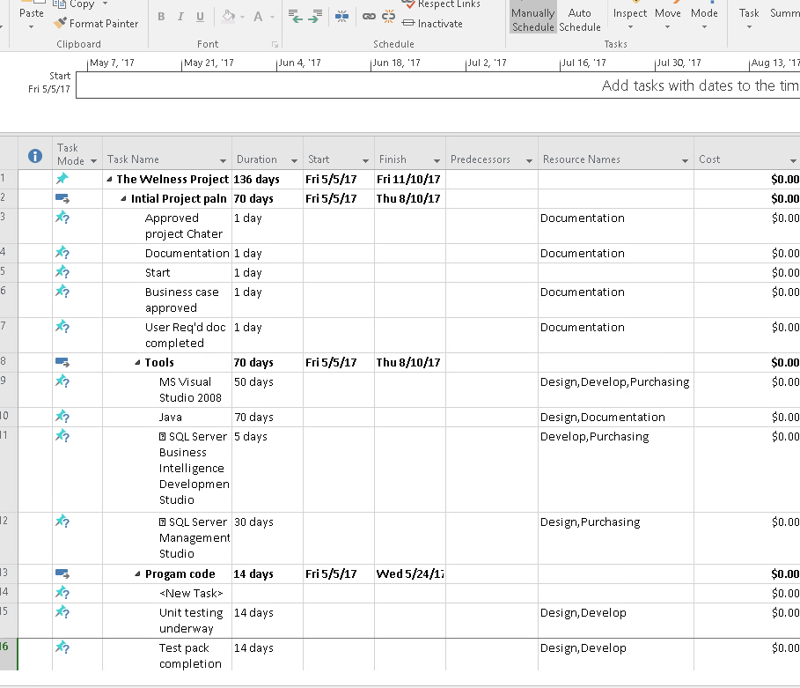

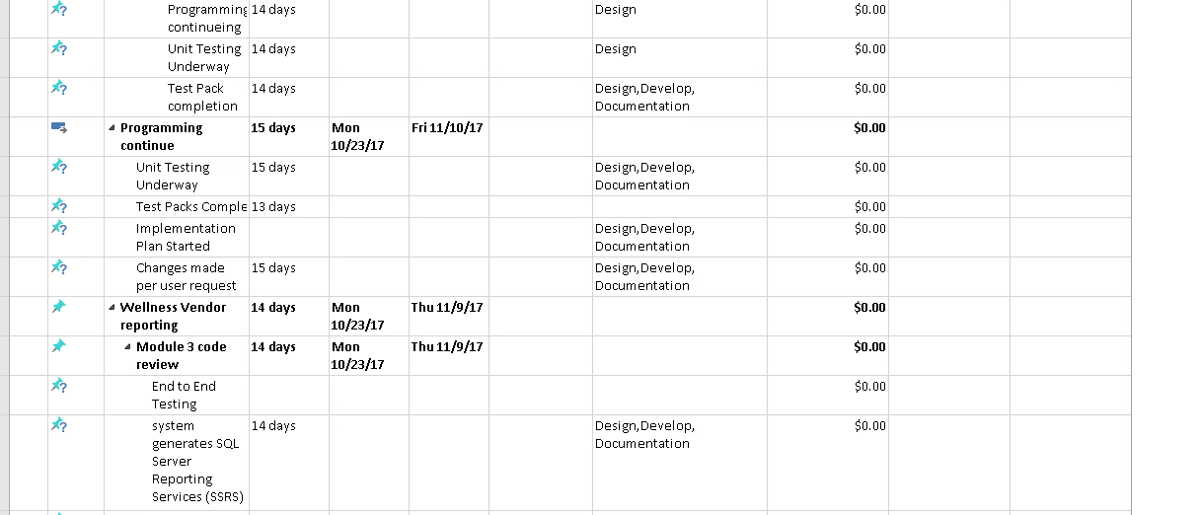

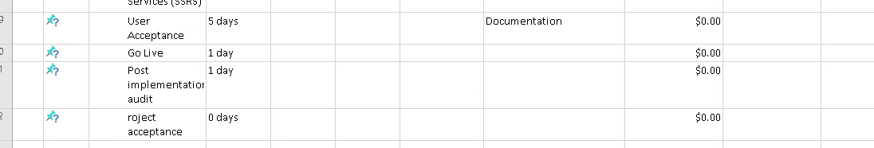

**Inputs necessary to the precedence diagram include the following:**

1. Numbered activity list

2. Logic network diagram

3. Summary of activity durations.

The Resource sheets completed during the estimating process provide the required resource information and activity duration times. The manager uses activity block information to calculate the critical path through forwarding and backward pass methods.

Each node of the logic network takes the form of an activity block during precedence diagram development.

|  |  |  |  |  |  |
| --- | --- | --- | --- | --- | --- |
| Activity Number | | | Activity Duration | | |
| Early Start | | Activity Description | | Early Finish | |
| Late Start | Total Float | | Free Float | | Late Finish |
|  |  |  |  |  |  |

**(Activity Block**)

(Deluca, 2012)

The manager quickly identifies which tasks critically managed to ensure a minimized project duration using:

1. Forward pass

2. Backward pass

3. Total float (TF), free float (FF), and critical path.

An Early Finish (EF) **equals** ES **plus** Duration, Total Float **equals** LS **minus** ES or LF minus EF, and LS **equal**s LF **minus** Duration. By doing a forward pass and a backward pass, the project manager can establish project activities' start and finish dates (Deluca, 2012).

The extra training on SQL Servers could impact on the project. For example, the people who do require training could affect how we have an early finish**.** Calculations provide the manager with a timeframe for each activity. Inability to complete each activity within its timeframe causes activity, task, or project delays.

Planned and Actual Tasks Report keeps track of tasks' progress against the due date applied. The feature makes it easier to know how projects are going than the plan (Hanley,2021). The time it takes to complete an activity must be documented. If the next move requires similar work, we will monitor the steps easily by following a checklist.

**Forward pass:**

The first activity and plugs in a zero for its ES Day (project workday). By adding the duration of that activity to the ES Day, the manager computes the EF day. If any, the EF day for activity plus lag becomes the ES Day for the next exercise.

Lag times are mandatory wait times between activities. A typical example is concrete cure time, where the lag is several days to several weeks after placing concrete before the crew can strip the forms.

**Backward Pass:**

The backward pass determines the late start (LS) times. The last activity and makes the late finish (LF) day the same day as the EF day (Deluca, 2012). By subtracting the duration from the LF day, the manager computes the LS day. If any, the LS day minus lag becomes the LF day for the preceding. Calculating the forward and backward pass will help project managers explain the reason for early and late completion in reports.

Calculate TF on a forward pass. The following equation computes the TF in the precedence diagram: TF equals LS − ES or LF − EF. Free Float is the number of days reducing Float from the follow-on activity by delaying its ES date. Free float calculation always uses the early days and occurs on a backward pass (Deluca, 2012).

This compression occurs in the project's execution phase to catch up if the project falls behind schedule. The reasoning will be helpful with the vendor project as the new project manager and the project team complete training on the SQL servers.

**Start-to-Start Logic Equations Start-to-start logic equations follow:**

|  |  |  |  |  |  |  |
| --- | --- | --- | --- | --- | --- | --- |
| **Forward Pass** | **Backward Pass** | **Total Float TF** | Free Float FF | **Forward Pass** | **Backward Pass** | **Total Float** |
| ES + DUR = EF | LF − DUR = LS, | LS − ES | ES (next activity) − Lag − ES. | ES + DUR = EF, EF + Lag = EF (next activity) | LF − DUR = LS, LF − Lag = LF (preceding activity) | LS − ES or LF − EF Free Float FF = EF (next activity) − Lag − EF |
| ES + Lag = ES (next activity) | LS − Lag = LS (preceding activity) |  |  |  |  |  |

(Deluca, 2012)

**Project Risk Planning:**

Project Risk planning identifies risk, analyzes potential risk, assigns priority to threats, and mitigates and monitors the amount of uncertainty in the Vendor project and how to manage it. The risk is dependent on the delivery date. **T**he two-week duration will give enough time to do testing, complete the checklist, and maintain. Missed due changes happen in the user requirement.

Project supervisors and crew leaders develop a project QC plan. The Project Scope Sheet Project supervisors create a project scope sheet for inclusion in the QC plan to comply with government relegations and standards. The plan is maintained by the vendor.

Project supervisors and crew leaders develop a project QC plan. The Project Scope Sheet Project supervisors create a project scope sheet for inclusion in the QC plan.Most projects will have a QC planner to observe any issues or upcoming issues with the requirements and what approach the team is using.

The project supervisor and assigned crew leaders annotate plans and specifications to establish the project's QC requirements concurrent with developing the **project** estimate. The QC requirements list a worksheet, capturing the specification or drawing reference number, the QC requirement, and control measure/remarks from the annotated plans and specifications for the requirements list worksheet. The managerial process will help with organization or plans, worksheets, resources, and numbers for the duration.

The project supervisor and assigned crew leaders create the project QC plan by consolidating a summary list of QC requirements by activity number. The QC specialist validates the project supervisor's QC plan using an independently developed QC inspection plan. The QC specialist's quality control inspection plan is what the QC specialist will use to verify that the project crew correctly completed each QC element.The reconciled QC plan provides data for the project supervisor to create the preparatory and initial phase checklists. It also provides data for the QC specialist's daily QC inspections incorporating the follow-up phase checklist. The QC will determine the hardware and software is up to date; hardware parts are calibrated along with test tools.

The project supervisor and crew leaders identify on-site testing requirements and engineering unit testing capabilities as they analyze QC requirements on each **resource** sheet. They create the project's QC testing plan and log by consolidating a summary list of QC testing requirements by activity number.

The QC manager/QC specialist maintains each project's official QC testing log.The project supervisor monitors the reconciled program and flags the two-week schedule to notify required personnel of the testing schedule and to ensure testing service requests are submitted well in advance. For the Vendor project, the QC specialist validates the project supervisor's QC testing plan using an independently developed QC testing plan.

The project supervisor, QC specialist, and QA representative agree on the various tests' requirements. For example, use **SQL help** to perform a test on the SQL servers and use W3schoolProject supervisors and assigned crew leaders to identify testing equipment requirements and submit the requirements to the QC manager.

**Risk Control**

Assessing impact is an exercise in structured imagination (Hulett,2004). A typical two-dimensional definition of risk in project management is an uncertain event or condition that, if it occurs, has a positive or a negative impact on a project objective (Hulett,2004). The vendor's project risk happened when the previous project manager departed. The risk includes team members attending SQL training in the middle of the project. It will require the team to pick up the trainee slack while they are gone.

The other dimension of risk is less amenable to assessment, however. Risk practitioners and project teams have trouble assessing the probability that a given chance might occur (Hulett,2004). It is relatively simple to determine the effect of risk since this merely requires defining the situation after the threat has occurred and estimating the possible impact on each objective.

The project is over budget by 20%. The third and final module for the final payment of **$75,000** was 75% of the total vendor cost. The module has not been tested yet. There is no communications plan, no risk plan, no systems implementation plan, and no incremental cost of ownership (TCO) fee schedule.

Managers use time buffers to slow down potential delays in the project (Puscasu,2022). Uncertainty in the project should reserve for the schedule. **There must be a discussion about overtime and working from home. Work from home could be risky and lead to problems and delays over time.**

**Buffers:**

1. Activities with severe risks.
2. Merged activities are prone to delays due to one or more preceding activities being late.
3. Activities that require scarce resources to ensure the resources are available when needed. Noncritical activities reduce the likelihood that they will create another critical path.

**There are two types of contingencies typically used on projects:**

* Budget contingency: Additional funding to deal with problems, realized risks relating to a specific event
* Schedule contingency: A buffer of extra time in case of schedule delays ([Harrin](https://projectmanagementrebels.com/),2022).

Take the cost baseline, add mitigation costs for dealing with 'general' risks and residual risks, and that will give you the project's final cost.

The CPM is not a cure-all for engineering problems. The CPM assists the manager in planning, scheduling, and controlling the project. Using the CPM reduces the risk of overlooking essential tasks and provides a blueprint for long-range planning and coordination of the project.

**Conclusion**

The Scope is the set of boundaries that define the extent of a project. The scope describes what is to be delivered to the customer because of the project initiative (Stricker, 2019).

The project team and legal must open and communicate. A couple of suggestions, create a communications team. Diligent research. Researching code styles will assist coders with perplex coding per the stakeholder's requirements. Create a log of code that works and does not work. Implement a checklist.

The project checklist is another type of assistant paperwork. It details the objective, which is the first step in creating the scope. It answers the question of who, what, and how much. The next step is to define deliverables. Deliverables are the expected outputs over the life of the project. Deliverables include a reference report that consists of a technical manual and software coding. Prototype testing is part of the final phase, providing final tests and approved software.

There are two types of contingencies typically used on projects:

* Budget contingency: Additional funding to deal with problems, realized risks relating to a specific event
* Schedule contingency: A buffer of extra time in case of schedule delays

Risk involves a lot of managerial skills. Risk involves activity hazard analysis.

Early Finish (EF) = ES + Duration, Total Float = LS – ES or LF – EF, and LS = LF – Duration. The project manager can establish project activities' start and finish dates by doing a forward pass and a backward pass. Understanding forward pass and backward pass is crucial for a project manager (Timechart,n.d).

The format of a Risk Management Plan varies by organization and is contingent on the analysis of existing systems and historical data.

* Education & Training
* Purpose, Goals, & Metrics
* Communication Plan
* Contingency Plans
* Reporting Protocols
* Response & Mitigation

The added risk is outsourcing, taking long hours to complete an activity. Use time buffers. The communication team comprises people from all departments, legal, administration, and Human resources. The QC planner will monitor the risk plan. The project manager creates the contingency plan, and they will decide the next course of action if the project appears to be failing. Reporting protocols days and weeks pass for upper management and review.

**Steps for long term projects:**

**Step 1:** Make sure the project scope is crystal clear.

**Step 2:** Document and prioritize tasks.

**Step 3:** Manage the agreed-upon scope.

**Step 4:** Keep focused when there are distractions or priority shifts.

**Step 5:** Wrap up the project.

Step 6: create a Standard Operating Procedure

Step 7: Lessons learned

**Reference:**

# [Harrin,](https://projectmanagementrebels.com/) E (April 8, 2022). **Project Contingency: The Ultimate Guide. Retrieved on July 10, 2022, from** <https://rebelsguidetopm.com/project-contingency/>

[Puscasu,](http://apepm.co.uk/author/alexpuscasu/) A (February 21, 2022). Risk Management Framework: Contingency Funding and Time Buffers. **Retrieved on July 17, 2022, from**<http://apepm.co.uk/risk-management-framework-contingency-funding-and-time-buffers/>

n.a(March,31, 2021). **How to Manage Project Risk: A 5-Step Guide. How to Manage Project Risk: A 5-Step Guide Retrieved on July 17, 2022, from**

<https://www.coursera.org/articles/how-to-manage-project-risk>

Hanley, E (March 31, 2021). **Introducing Planned vs. Actual Tasks Report. Retrieved on July 25, 2022, from** <https://www.teamwork.com/blog/introducing-planned-vs-actual-tasks-report/>

n.a(2021, July 14) Critical path method: How to use CPM for project management. **Retrieved on July 25, 2022, from** [https://asana.com/resources/critical-path-method\](https://asana.com/resources/critical-path-method/)

Hillson, D (2004). Assessing risk probability. **Retrieved on July 25,2022 from** <https://www.pmi.org/learning/library/assessing-risk-probability-impact-alternative-approaches-8444#:~:text=It%20is%20common%20to%20use,materialised%20(the%20effect%20dimension>).

Deluca, P (December 2012). Construction Management. Retrieved on July 10, 2022, from <https://www.marines.mil/Portals/1/MCRP%203-17.7F%20z.pdf>

# n.a n.d. Project Management Statistics: Trends and Common Mistakes in 2022 retrieved on July 12, 2022, from <https://teamstage.io/project-management-statistics/#:~:text=According%20to%20project%20management%20success,%25%20and%2060%25%2C%20respectively>.

n.a, n.d. Foward and backward pass. Retrieved on July 12, 2022, from <https://tiemchart.com/blogs/training/forward-pass-and-backward-pass/>

STRICKER, K(June 15, 2019). Scope, Risk, and Assumption in Project

Management.

## n.d n.a. But What Exactly Are Team Dynamics? Retrieved on August 5, 2022, from https://www.rallybright.com/understanding-team-dynamics

# n.d n.a Which of these 7 different styles of leadership is right for your business? Retrieved on August 10 2022 from <https://www.micromentor.org/blog/en/which-of-these-7-different-styles-of-leadership-is-right-for-your-business/?gclid=Cj0KCQjwxb2XBhDBARIsAOjDZ36cgYbk6y5ncsyRc3i9AD97cHx0nsUUvTTVBo2ocEnwxw9SkSKHTQIaAn04EALw_wcB>

# **n.a n.d.The Savvy PMO's Guide to Prioritization. retrieved on august 1, 2022 from https://info.planview.com/savvy-pmo-guide-to-prioritization-_ebook_prm_en_reg.html?utm_medium=psem&utm_source=google&utm_campaign=in_mitppm_g-proj-mgmt-office_digmc_na_x_en&utm_content=478920204401&utm_term=%2Bprogram%20%2Bmanagement%20%2Boffice&gclid=CjwKCAjw6MKXBhA5EiwANWLODIu0MH6NnKoG_Rf6qeJPwXbN9w4cdDoyaob3jeNNMaYXdN0nRWbYzBoCDZ0QAvD_BwE**

Hulett, D (2004). Assessing Risk Probability: Alternative. Retrieved on July 15, 2022, from Approacheshttp://www.projectrisk.com/white_papers/Assessing_Risk_Probability-_Alternative_Approaches.pdf

Watts, A(n.d).Project Schedule retrieved on July 20, 2022, from Planning.https://ecampusontario.pressbooks.pub/projectmanagement/chapter/chapter-10-project-schedule-planning-project-management/

# **PayScale(n.d)Average Information Systems (IS) Manager Salary. Retrieved on July 23, 2022 from https://www.payscale.com/research/US/Job=Information_Systems_(IS)_Manager/Salary**

Teradata (n.d) . Teradata Database Design. Retrieved on July 31,2022 from

https://docs.teradata.com/r/ji8nYcbKBTVEaNYVwKF3QQ/7nYTszdJe_YUTc1O40jLHA